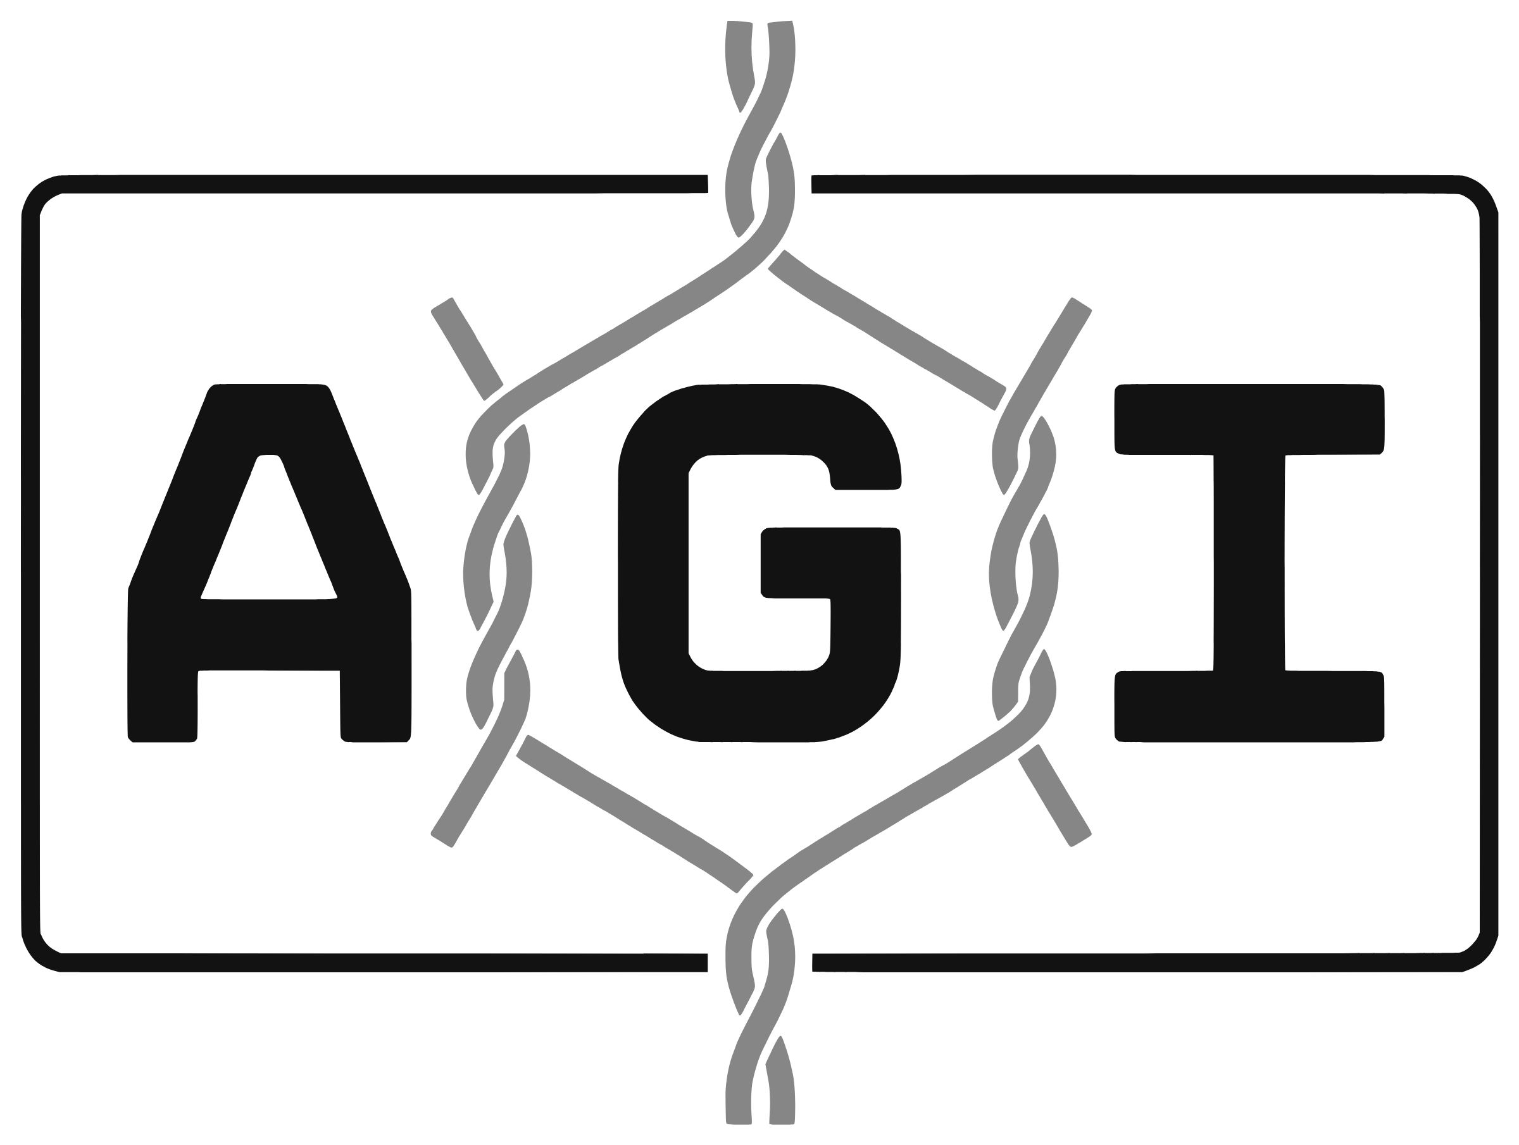
Method Statement for Construction of Gabion Retaining Wall
Replace everything in [square brackets]. Delete the guidance notes in grey before issue.
Field | Details
Project | [Project name and location]
Client / Employer | [Client]
Engineer-in-charge / Consultant | [Name, organisation]
Contractor | [Contractor]
Work / BOQ item | [e.g. Gabion retaining wall, ch. 0+000 to 0+250, BOQ item ...]
Drawings | [Drawing numbers and revisions]
Gabion specification | [e.g. 2 x 1 x 1 m, mesh type 10x12, 2.70 mm GI / PVC coated, to IS 16014:2024]
Document no. / Revision / Date | [ ] / [ ] / [ ]

 | Name | Designation | Signature | Date
Prepared by
Checked by
Approved by

1. Purpose and scope
- This method statement sets out how gabion retaining walls are built on this project: storage, foundation preparation, assembly, lacing, filling, closing, backfilling, inspection and records.
- It covers gabion boxes to IS 16014:2024 in galvanized or PVC coated wire, filled on site with stone. Underwater placement and prefilled units are covered in their own section.

2. References
- IS 16014:2024 — mechanically woven double twisted hexagonal wire mesh gabions, revet mattresses and rockfall netting
- IRC:SP:116-2018 — Guidelines for Design and Installation of Gabion Structures, section 8
- IS 14458 (Part 6):2020 — Retaining wall for hill area: construction of gabion walls
- Approved drawings, technical specification and BOQ for the work
[Add the contract technical specification clause numbers here.] Clause tags in square brackets, e.g. [IRC 8 (7)], point to IRC:SP:116-2018 or IS 14458 (Part 6):2020.

3. Responsibilities
- Project manager — resources, programme, and approval of this method statement.
- Site engineer — setting out, levels, foundation approval, and the inspection checklists.
- Supervisor / foreman — assembly, lacing, filling and backfilling as set out below.
- Quality engineer — material acceptance, density tests, porosity checks and records.
- Safety officer — toolbox talks, PPE, lifting and excavation safety.

4. Materials
- Gabion boxes to IS 16014:2024, of the mesh type, wire diameters, coating and sizes on the drawing, delivered folded in bundles with their lacing wire (and fastener rings if specified), with the manufacturer’s test certificate.
- Stone fill: hard, fresh, durable rock that does not break down in water; preferred size 150–300 mm, no stone larger than two-thirds the depth of the unit or 300 mm, and the smallest dimension at least twice the mesh opening. [IS 14458-6 cl 4.2] Weathered rock is not used.
- Geotextile: non-woven, Type III behind walls, Type I in river and marine works. [IRC 6.1, 4.3]
- Backfill: selected material as specified, placed out to the 45° + φ/2 line. [IRC 6.7]

5. Plant, tools and equipment
- Excavator or backhoe; vibratory roller of 8–10 t; plate compactor or walk-behind roller of about 1 t for work within 1.5 m of the wall face. [IRC 8 (3), (17)]
- Survey instrument and levelling staff; measuring tapes; string lines.
- Lacing tools, pliers, wire cutters, crowbars and wooden mallets; ring-closing tool if rings are used.
- MS pipe or steel frame formwork for the exposed face. [IRC 8 (12)]
- Crane with lifting frame where prefilled units or underwater placement are used.

6. Delivery, storage and handling
- Unload bundles by machine without dragging or dropping them, and store them close to where they will be used. [IRC 8]
- Stack no more than four bundles high, on level ground with timber sleepers between bundles. [IRC 8]
- Do not store bundles on abrasive or chemically aggressive surfaces — asphalt, oil, grease, chemicals. [IRC 8]
- Check each bundle against the delivery note and test certificate before use.

7. Setting out and foundation
- Mark the alignment of the wall face from the drawings before excavation. [IRC 8 (4), 8.4]
- Excavate to the levels on the drawing. If a good bearing stratum is not found at that level, stop and inform the Engineer-in-charge. [IRC 8 (1)]
- Remove loose pockets and deleterious material and refill with compacted granular material. [IRC 8 (1)]
- Clear standing water. If the excavation cannot be dewatered, place filled units under water as described below. [IRC 8 (2)]
- Compact the formation with an 8–10 t vibratory roller to at least 95% of modified Proctor density; use a plate compactor where the roller cannot reach. Test the density and check the levels before placing any unit. [IRC 8 (3), 8.4; IS 14458-6 cl 7.1]

8. Assembly of gabion units
- Open each unit on a hard, level surface and check the mesh for damage. [IRC 8 (5), 8.5.1]
- Stretch the unit to remove folds and straighten the selvedge (edge) wires with a wooden mallet. [IRC 8.5.1]
- Raise the sides, ends and diaphragms and tie the top corners with the selvedge wire, so that all four corners are square and the box is the size on the drawing. [IRC 8 (5), (6)]
- Check that every diaphragm is in place and every vertical panel is at the same level before lacing starts. [IRC 8.5.1]

9. Lacing
- Lace every edge in one continuous operation, starting at a top corner, with alternate single and double loops through every mesh opening (100–125 mm). [IRC 8 (7); IS 14458-6 cl 7.2]
- Secure the ends of the lacing wire at each corner and turn them into the box. Do not use individual ties. [IRC 8 (7)]
- Where specified, IS 16014 fastener rings applied with a mechanical tool may be used instead of lacing. [IRC 8 (7)]

10. Placing and connecting units
- Place the empty units on the prepared foundation to the alignment of the face. [IRC 8.5.2]
- Lace each unit to its neighbours along all touching edges before any stone is placed. [IRC 8.5.2]
- Stagger the vertical joints between courses so that no continuous vertical joint runs through the wall. [IS 14458-6 cl 7.2]
- Fix MS pipe or frame formwork on the exposed face to hold the face line and limit bulging during filling. [IRC 8 (12)]

11. Filling
- Place selected stones with a flat face outward on the exposed face first, then fill the body of the unit with minimum voids. Machines may be used to deliver the stone; the face is hand-placed. [IRC 8 (9)]
- Fill in layers not exceeding 300 mm, and never let one cell stand more than 300 mm higher than the cell next to it — fill neighbouring cells together. [IRC 8 (11), 8.5.3]
- Fit internal tie (bracing) wires: in 1 m high units at one-third and two-thirds height, in 0.5 m units at half height. [IRC 8 (10)]
- Overfill by about 25–50 mm to allow for settlement of the fill. [IRC 8 (11)]
- Check the mesh for damage as filling proceeds.

12. Closing the lids
- Fold the lid down and lace it first to the front panel, then to the ends and to every diaphragm. [IRC 8 (13)]
- Lace each unit of the course above to the course below along the front and back edges, and join the faces of adjoining units along their vertical and top edges. [IRC 8 (13); IS 14458-6 cl 7.3]

13. Geotextile, backfill and compaction
- Lay the non-woven geotextile against the rear face of the gabions before backfilling. [IRC 8 (15)]
- Place the backfill in layers of 200–300 mm and compact each to 95% of modified Proctor density with an 8–10 t roller; within 1.5 m of the wall use a plate compactor or walk-behind roller of about 1 t. [IRC 8 (16), (17); IS 14458-6 cl 7.5]
- Raise the backfill together with the wall, course by course — never complete the wall first.
- Seal the top 500 mm of backfill with natural or clayey soil to keep surface water out. [IS 14458-6 cl 4.3, 7.5]
- Repeat assembly, lacing, placing, filling, closing and backfilling for each course up to the top of the wall.

14. Underwater placement and prefilled units
- Where units cannot be built in the dry, fill them near the site and place them by crane, from the bank or a barge-mounted crane. [IRC 8.2, 8.3]
- Thread 16–20 mm steel bars through the top perimeter of each filled unit so the crane hooks lift without damaging the mesh; keep lifting points no more than 1 m apart. [IRC 8.2]
- Lower the unit with divers guiding the operator, release under water, and wire each unit to its neighbour with wire of the same specification as the mesh. On steep slopes, anchor mattresses at the top with short piles. [IRC 8.2]

15. Inspection and quality control
- Foundation: alignment marked, levels as drawing, weak pockets replaced, density ≥ 95% modified Proctor. [IRC 8.4]
- Units: no mesh damage, square corners, diaphragms in place, dimensions checked. [IRC 8.5.1]
- Lacing: continuous single/double loop at every mesh opening, or rings; ends secured. [IRC 8.5.1]
- Filling: stone to specification, layers ≤ 300 mm, tie wires fitted, porosity 30–40%. [IRC 8.5.3]
- Porosity check by weighing: a filled 1.5 × 1 × 1 m box at 35% voids with stone of 26 kN/m³ should weigh about 2.5 t; much lighter means too many voids. [IRC 8 (9); IS 14458-6 cl 7.4]
- Levels of the finished wall taken at least every 10 m along its length. [IRC 8.5.3]
Inspection checklist — one per wall section [ch. ____ to ____], course [ ]
Stage | Check | Reference | OK | Remarks / test ref.
Foundation | Alignment marked; levels as drawing; weak pockets replaced | IRC:SP:116 8.4
Foundation | Compaction at least 95% modified Proctor (test reference) | IRC:SP:116 8 (3)
Materials | Gabions to IS 16014:2024; test certificate received | IS 16014
Materials | Stone hard and durable, 150-300 mm, not weathered | IS 14458-6 4.2
Assembly | No mesh damage; corners square; diaphragms in place | IRC:SP:116 8.5.1
Lacing | Continuous, alternate single/double loop every mesh (or rings); ends secured | IRC:SP:116 8 (7)
Placing | Units laced to neighbours; vertical joints staggered | IS 14458-6 7.2
Filling | Layers not over 300 mm; cells within 300 mm of each other | IRC:SP:116 8 (11)
Filling | Tie wires at 1/3 and 2/3 (1 m) or 1/2 (0.5 m) height | IRC:SP:116 8 (10)
Filling | Porosity 30-40% (weigh check: 1.5 x 1 x 1 m box about 2.5 t) | IS 14458-6 7.4
Lids | Laced to front, ends and diaphragms; courses connected | IRC:SP:116 8 (13)
Backfill | Geotextile on rear face; 95% MPD; light plant within 1.5 m | IRC:SP:116 8 (15)-(17)
Backfill | Top 500 mm sealed with natural / clayey soil | IS 14458-6 7.5
Finished wall | Levels recorded at least every 10 m | IRC:SP:116 8.5.3

16. Health and safety
- Toolbox talk before work starts; PPE at all times — helmet, safety shoes, gloves for wire handling, eye protection when cutting wire.
- Batter or support excavation sides; keep stockpiles and plant back from the edge.
- Lifting operations under a competent signaller; nobody under a suspended load.
- Life jackets and a rescue line for any work in or beside water.

17. Records
- Material test certificates and delivery notes; foundation and backfill density test results.
- Inspection checklists for each section of wall; porosity check results; level records.
- Daily progress record and any instructions from the Engineer-in-charge.

